H.T No
Regulations:
A17

Sreenidhi Institute of Science and Technology
(An Autonomous Institution)
Code No: 6B621 Date: 15-July-2021(FN)

B.Tech III-Year II-Semester Pending External Examination, July-2021 (Supplementary)
CAD/CAM (ME)

Time: 3 Hours Max.Marks:75

Note: a) No additional answer sheets will be provided.
b) All sub-parts of a question must be answered at one place only, otherwise it will not be valued.
c) Missing data can be assumed suitably.

ANSWER ANY 5 OUT OF 8 QUESTIONS. EACH QUESTION CARRIES 15 MARKS.

Bloom's Cognitive Levels of Learning (BCLL)

Remember | L1 | Apply | L3 | Evaluate | L5
Understand | L2 | Analyze | L4 | Create | L6

 |  |  | BCLL | CO(s) | Marks
1. |  | Explain the basic techniques used in graphics terminal for generating image on the CRT screen. | L2 | CO1 | [15M]
2. | a) | The vertices of a triangle are situated at points (15,30), (30,40) and (25,60). Find the coordinates of the vertices if the triangle is rotated by 30⁰ counter clockwise about its centroid. | L4 | CO2 | [8M]
 | b) | What is two dimensional transformation. |  | CO2 | [7M]
3. | a) | What is ruled surface? Derive its parametric equation. | L2 | CO3 | [8M]
 | b) | Differentiate between the approximation and interpolation of curves. | L3 | CO3 | [7M]
4. |  | Explain the constructional structure of CNC machine tools. | L2 | CO4 | [15M]
5. | a) | Explain the working principle of machine vision system. | L2 | CO5 | [8M]
 | b) | What are the advantages and disadvantages of a wire model. | L2 | CO5 | [7M]
6. | a) | Explain the various elements of CIM. | L2 | CO6 | [8M]
 | b) | What is machining cnetre? | L2 | CO6 | [7M]
7. |  | Derive the parametric equation of Bezier curve. | L3 | CO1 | [15M]
8. |  | Write a manual part program to drill all the holes as shown in figure.  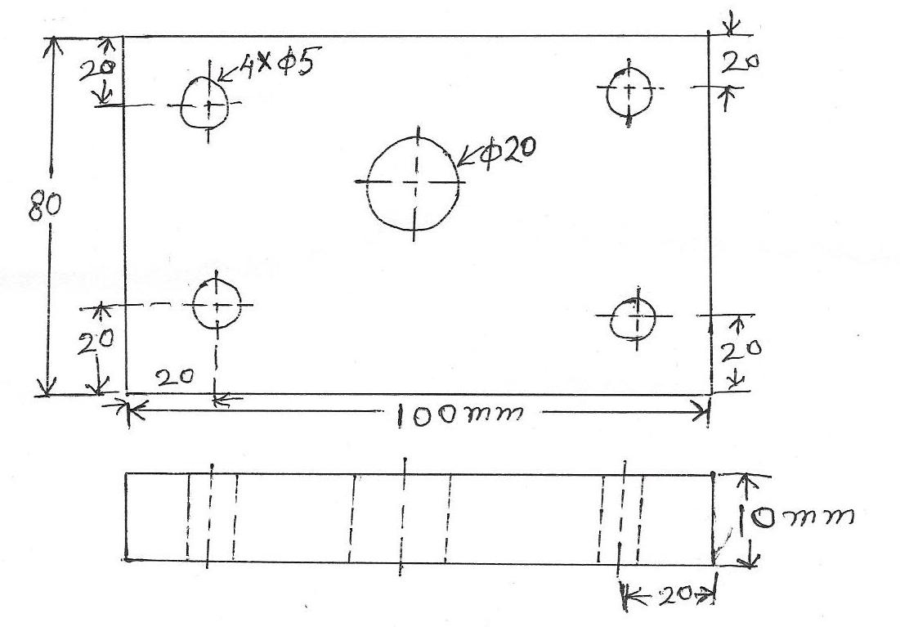 | L4 | CO4 | [15M]
-- 00 -- 00 –

